AFAR REGIONAL PORTAL
System, Frontend, Backend, Database & API Architecture
A modernization architecture derived from the project SRS — Laravel API + React (Next.js) frontend, preserving existing navigation and information architecture

Legend used throughout this document:
PRESERVES existing behavior unchanged IMPROVES same behavior, done better INTRODUCES net-new functionality

Date: July 20, 2026

Table of Contents

Introduction & Constraints
This document is the architecture that follows from the project SRS (Afar Regional Portal v2). It answers the ten questions requested — system, frontend, backend, database and API architecture; folder structure; phases; MVP scope; risks; and roadmap — under one governing constraint stated up front: this is a modernization, not a redesign.

Governing constraint
The existing public navigation and information architecture is preserved as the backbone of the new frontend: Home, About, Directory (directorates & city administration, organized into categories with nested sub-menus), News, Events, Tenders, Vacancies, Publications, and Contact remain the primary navigation, in that conceptual grouping. Nothing in this architecture renames, merges, or removes a top-level section a citizen currently knows how to find. Where a change is proposed, it is labeled:
[PRESERVES] existing behavior / navigation is unchanged. [IMPROVES] same behavior, delivered on better technology. [INTRODUCES] genuinely new functionality.

1. Complete System Architecture
The system keeps a monolithic Laravel backend (matching the team's existing PHP skill set) but exposes it exclusively through a versioned JSON API, and replaces server-rendered Blade views with two purpose-built React applications: a public site optimized for citizens (SEO-crawlable, fast, accessible) and an admin dashboard optimized for editorial staff (behind login, no SEO concern).
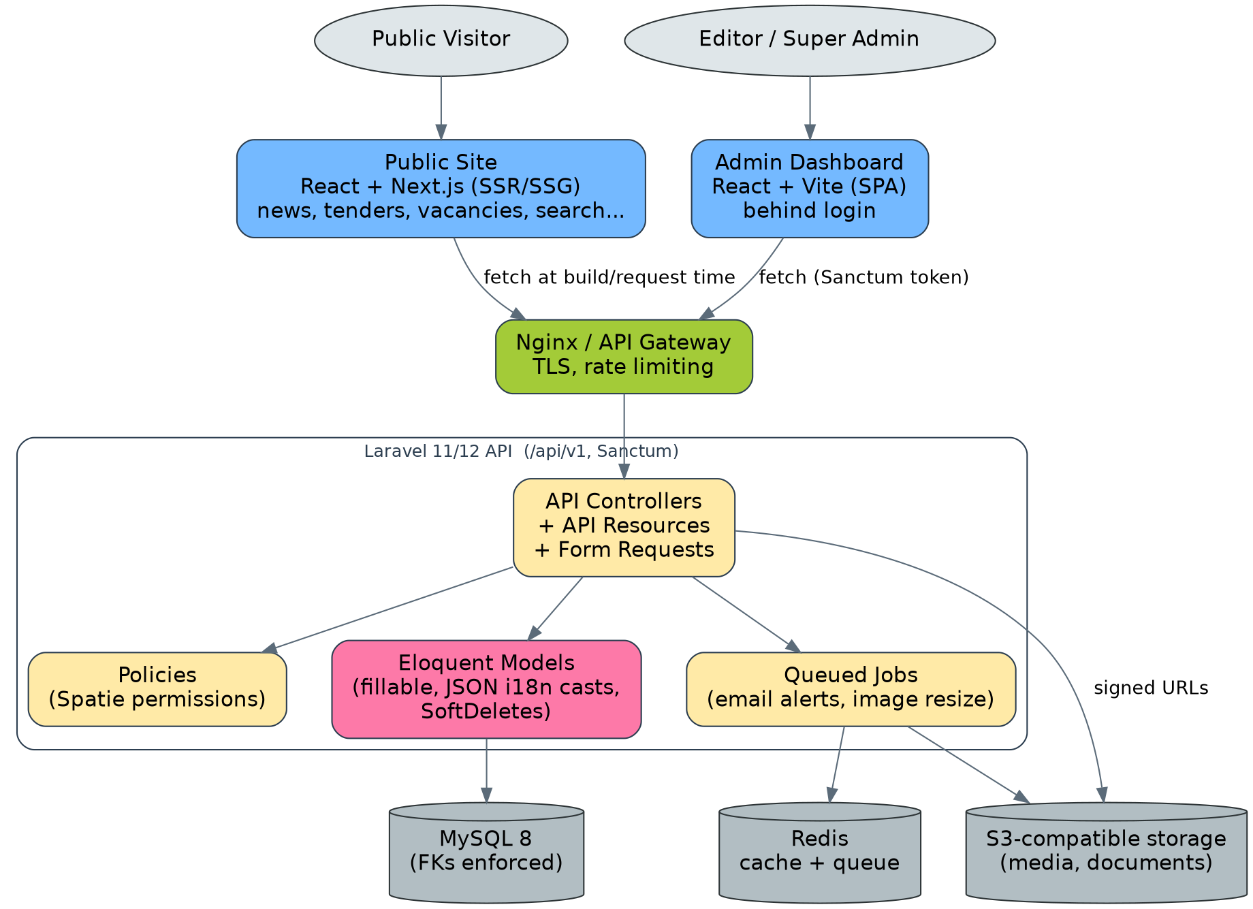
Figure 1. Complete system architecture.

1.1 Layer-by-layer summary
Layer | Technology | Responsibility | Classification
Edge / gateway | Nginx (or a managed load balancer) | TLS termination, static asset caching, rate limiting, routes traffic to the two frontends and the API | IMPROVES
Public frontend | Next.js (React), SSR/SSG | Renders Home, About, Directory, News, Events, Tenders, Vacancies, Publications, Contact using the existing navigation hierarchy | PRESERVES navigation / IMPROVES delivery
Admin frontend | React (Vite), SPA | Editorial dashboard — the old Blade admin theme, rebuilt as an app calling the API | PRESERVES functionality / IMPROVES UX
API | Laravel 11/12, versioned /api/v1 | All reads and writes; the only thing either frontend talks to | INTRODUCES (barely existed before)
Database | MySQL 8, normalized schema, real FKs | System of record | IMPROVES
Cache / queue | Redis | Response caching for public reads, background jobs (email, image resize) | INTRODUCES
File storage | S3-compatible object storage | Tender/vacancy/publication documents, images | IMPROVES (was local disk)

1.2 What does not change
- [PRESERVES] Backend language and framework family: Laravel/PHP, just on a current, supported version — no framework migration risk for the team.
- [PRESERVES] Bilingual content model: every public page still serves English and Amharic; the mechanism changes (see §4) but the citizen-facing behavior does not.
- [PRESERVES] Role concept: staff log in to an admin area to manage content; the public never authenticates.
- [PRESERVES] Top-level navigation and its grouping: Home / About / Directory / News / Events / Tenders / Vacancies / Publications / Contact, including nested categories under Directory.

2. Frontend Architecture
Two React codebases, sharing a common design-token/component philosophy but deployed and built separately, because they have different rendering requirements (public SEO vs. authenticated internal tool).
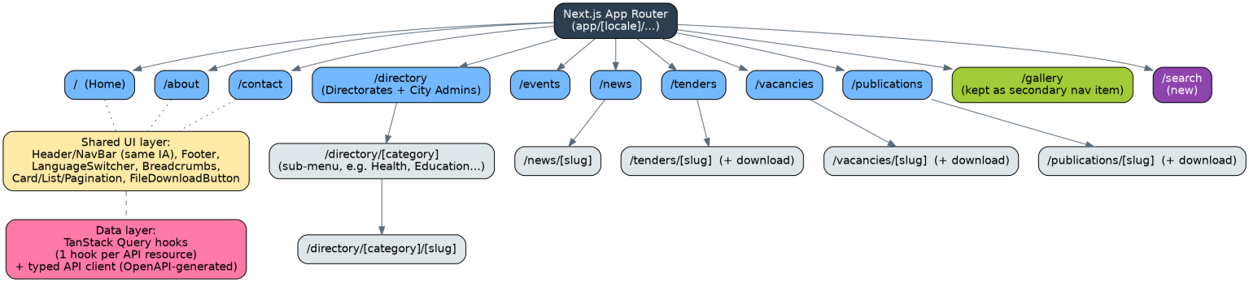
Figure 2. Public site route structure, mapped 1:1 onto the existing navigation.

2.1 Public site (Next.js)
Route | Old equivalent | Classification | Notes
/ | /{language}/ | PRESERVES | Homepage: hero/slider, latest news, quick links — same content blocks as today.
/about | /{language}/front-about | PRESERVES
/directory | /{language}/directorate/{type}, /cityAdmin/{type} | PRESERVES nav / IMPROVES structure | Directorates and City Admin profiles unified under one “Directory” section with category sub-menus, matching how citizens already conceptually group them.
/directory/[category] | /{language}/directorate/{type} | PRESERVES | Nested sub-menu per category, exactly as today's type-filtered listing.
/directory/[category]/[slug] | /{language}/directorateDetail/{id} | PRESERVES | Detail page + file download.
/news, /news/[slug] | /{language}/front-news, /detail/{id}/news | PRESERVES
/events | /{language}/front-event | PRESERVES
/tenders, /tenders/[slug] | /{language}/front-tender, /detail/{id}/tender | PRESERVES | Download button now uses a signed object-storage URL.
/vacancies, /vacancies/[slug] | /{language}/front-vacancy | PRESERVES
/publications, /publications/[slug] | /{language}/front-publication | PRESERVES
/contact | /{language}/front-contact | PRESERVES | Same form fields; submission now goes through the API.
/gallery | /{language}/front-gallery, /front-video | PRESERVES | Kept as a secondary nav item exactly as today (photo/video).
/search | — did not exist | INTRODUCES | New site-wide search across News/Tenders/Vacancies/Publications/Announcements.

Frontend architectural building blocks
- Routing: Next.js App Router with a [locale] segment, so /en/... and /am/... continue to exist as URLs (matching today's link-sharing behavior), but the active language additionally persists in a cookie so in-app navigation doesn't require re-selecting it on every click — an IMPROVES over the old system, which had no persistence at all.
- Data fetching: TanStack Query (React Query) wraps a typed API client generated from the OpenAPI spec (§5). One hook per resource (useNews, useTenders, ...), shared between server components (SSR) and client components (interactive bits like the search box).
- Shared component library: NavBar/Header (renders the exact same top-level items, including the Directory dropdown), Footer, Breadcrumbs, Card/List/Pagination, FileDownloadButton, LanguageSwitcher — built once, reused across every module page, so the visual language stays consistent site-wide.
- Rendering strategy: Static generation (SSG) with periodic revalidation for rarely-changing pages (About, Directory listings), server-side rendering (SSR) for frequently-changing lists (News, Tenders, Vacancies) so a newly published item appears immediately, and client-side rendering only for the search box and the contact form.
- Accessibility: semantic landmarks (nav/main/footer), skip-to-content link, keyboard-navigable Directory sub-menus, alt text required on every image field in the admin (enforced by a FormRequest rule), and color-contrast-checked design tokens — an IMPROVES over the old Blade/Bootstrap admin theme, which was not audited for accessibility.

2.2 Admin dashboard (React + Vite SPA)
- Navigation mirrors the old admin sidebar 1:1 (News, Events, Tenders, Vacancies, Publications, Announcements, Directory, City Admins, Gallery, Sliders, About, Contact Messages, Users, Roles) so existing staff need minimal retraining — PRESERVES.
- Forms: React Hook Form + a schema validation library (Zod), with the validation schema kept in sync with the backend FormRequest rules to avoid duplicated/contradictory validation logic.
- Rich text / bilingual editing: a single form shows English and Amharic fields side by side per field (tabs or split view) since content is now stored as one JSON value — an IMPROVES over the old system's separate, disconnected “English form” and “Amharic form” fields.
- Auth: Sanctum SPA cookie authentication (login screen → session cookie → every API call authenticated automatically), matching the old session-based login flow conceptually — PRESERVES the login experience, IMPROVES the mechanism.

2.3 Global application loading experience
The old system had no loading experience at all — Blade pages simply appeared once the server finished rendering, or sat blank while they did. This is genuinely new (INTRODUCES) and is treated as part of the frontend architecture rather than a cosmetic add-on, because it directly serves the SRS's “better perceived performance” and “professional, government-appropriate feel” goals.

2.3.1 First-load application preloader
- [INTRODUCES] A full-screen, branded preloader (Afar Regional Government mark, on-brand color field, and a small animated flourish — a pulsing or rotating variant of the emblem, not a generic spinner) is shown the instant the page starts loading, on both the public site and the admin dashboard.
- How it avoids feeling slow: the preloader markup and its styles are inlined directly in the initial HTML shell (not shipped as a separate JS bundle the browser has to fetch first), so it paints immediately — before React/Next.js hydrates — the same trick YouTube and Instagram use to avoid a blank white screen on first paint.
- When it clears: the preloader is tied to actual application-ready state (critical data fetched, fonts loaded, React hydrated) rather than a fixed timer, then fades out over ~300–400ms using an opacity transition into the real homepage — no hard cut.
- Perceived-performance guardrails: a minimum display time (~400–500ms) prevents an unpleasant “flash” on fast connections, and a maximum reasonable ceiling (e.g. a subtle progress indicator appears if initialization runs past ~3s) prevents it from ever feeling stuck — both bounds are configuration, not hard-coded waits, so they can be tuned after real-world measurement.
- Accessibility: the preloader is marked with role="status" and aria-live="polite" so screen readers announce “Loading Afar Regional Portal” once, not repeatedly; the animation respects prefers-reduced-motion by falling back to a static branded screen instead of a moving mark.

2.3.2 In-app navigation / page-transition indicator
- [INTRODUCES] A lightweight top-of-viewport progress bar (the same pattern GitHub, YouTube, and most modern government portals use) appears during client-side route changes and any data fetch expected to take longer than ~200ms — short enough fetches show nothing at all, so the indicator never appears for near-instant navigations.
- Where it lives technically: Next.js App Router's built-in loading.tsx/Suspense boundaries drive route-level transitions on the public site; the same top-progress-bar component is reused in the admin SPA, driven by TanStack Query's global fetching state so any significant API call (not just route changes) triggers it.
- Content-area loading: individual content regions (a News list re-filtering, a Directory category switching) use skeleton placeholders shaped like the real content rather than a spinner, which is both calmer visually and communicates layout before data arrives — standard modern-portal practice, distinct from the full-screen preloader which is first-load only.

2.3.3 Component ownership
Component | Scope | Lives in
AppPreloader | First paint only, both frontends | components/AppPreloader (public), src/components/AppPreloader (admin) — shares one design-token-driven implementation
PageTransitionIndicator | Route changes + long-running fetches | components/PageTransitionIndicator, wired to Next.js loading.tsx and to the admin SPA's router + TanStack Query state
ContentSkeleton | Per-module placeholder shapes (list rows, detail page, form) | components/skeletons/*, one per content shape reused across modules

3. Backend Architecture
The backend keeps Laravel's MVC foundation but adds the layers the old codebase was missing: FormRequests for validation, Policies for authorization, and thin Service/Action classes so controllers stop doing file-handling and business logic inline (as several of the old controllers did).
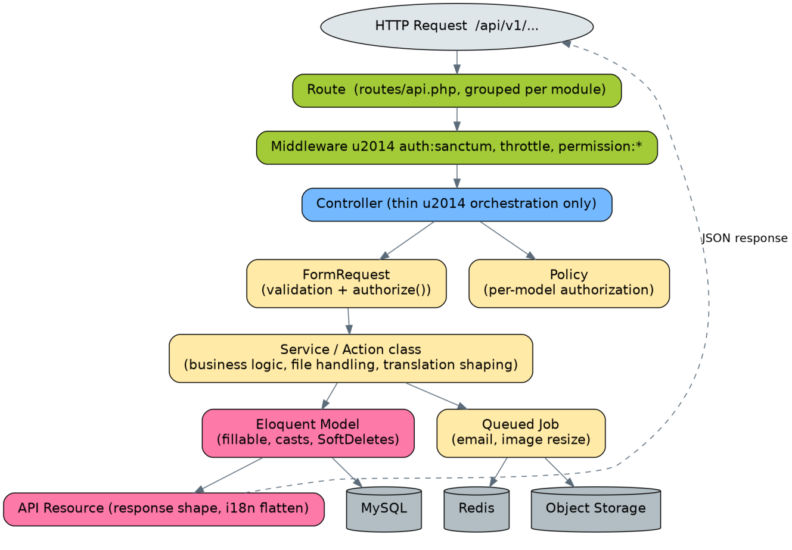
Figure 3. Request lifecycle through the backend layers.

3.1 Layer responsibilities
Layer | Responsibility | Classification
Route | Maps a URL + HTTP verb to a controller action, grouped per module under /api/v1 | INTRODUCES (old api.php was empty)
Middleware | auth:sanctum, throttle, permission:{module}-{action} (Spatie) — same permission names as the old system | PRESERVES permission model / IMPROVES enforcement
Controller | Thin — calls a FormRequest, calls a Service, returns a Resource. No file handling, no raw SQL. | IMPROVES
FormRequest | Validates input and answers “is this user allowed to do this” for the specific action | INTRODUCES (was inconsistent/absent)
Policy | Model-level authorization (can this Editor edit this Tender?) | INTRODUCES
Service / Action class | Business logic: file upload handling, translation JSON shaping, publish-scheduling logic, search indexing | INTRODUCES (logic was inline in controllers)
Eloquent Model | Data + relationships; $fillable allow-lists, SoftDeletes, casts for JSON i18n fields | IMPROVES (old models used $guarded = [])
API Resource | Shapes the JSON response (flattens {"en":..,"am":..} the way the frontend expects) | INTRODUCES
Queued Job | Anything slow: image resizing, outgoing email (contact replies, subscription alerts) | INTRODUCES (old system ran everything synchronously)

3.2 Module-to-controller map (mirrors the preserved navigation)
Each public navigation item maps to one backend module, keeping a 1:1 mental model between what a citizen sees and what the API/admin exposes — the same grouping the old system used, just consistently applied everywhere (the old Events module, for example, was missing edit/delete; the new one is a complete module like all the others).
- Home → aggregates Sliders + latest News + latest Announcements (no dedicated module of its own, same as today).
- About → AboutController (singleton resource).
- Directory → DirectorateController + CityAdminController + CategoryController (new, replacing the free-text category field).
- News → NewsController + shared MediaController for per-article image galleries.
- Events → EventController (now a complete CRUD resource).
- Tenders / Vacancies / Publications → one controller each, sharing a common FileUploadService for the download-attachment pattern.
- Contact → ContactController (public store + admin index/status update, new).
- Cross-cutting: SearchController (new), Auth/UserController/RoleController (Super Admin only, carried over from the old RoleController/UserController pattern).

3.3 Authentication & authorization flow
- Editor/Super Admin submits credentials to POST /api/v1/auth/login from the admin SPA.
- Sanctum issues a session cookie (SPA mode) scoped to the API domain.
- Every subsequent admin request carries the cookie automatically; Laravel resolves the authenticated user and their Spatie roles/permissions.
- Route middleware (permission:news-edit, etc.) blocks the request before it reaches the controller if the role doesn't have that permission — identical permission granularity to the old system, just actually populated with two roles instead of one.
- Public requests carry no auth at all; public GET endpoints are always anonymous and cached.

4. Database Architecture
The schema keeps every existing content type as its own table (nothing citizens rely on disappears) but fixes the structural problems identified in the code audit: unenforced foreign keys, duplicated per-language columns, a free-text category field, and an unfinished multi-image feature.
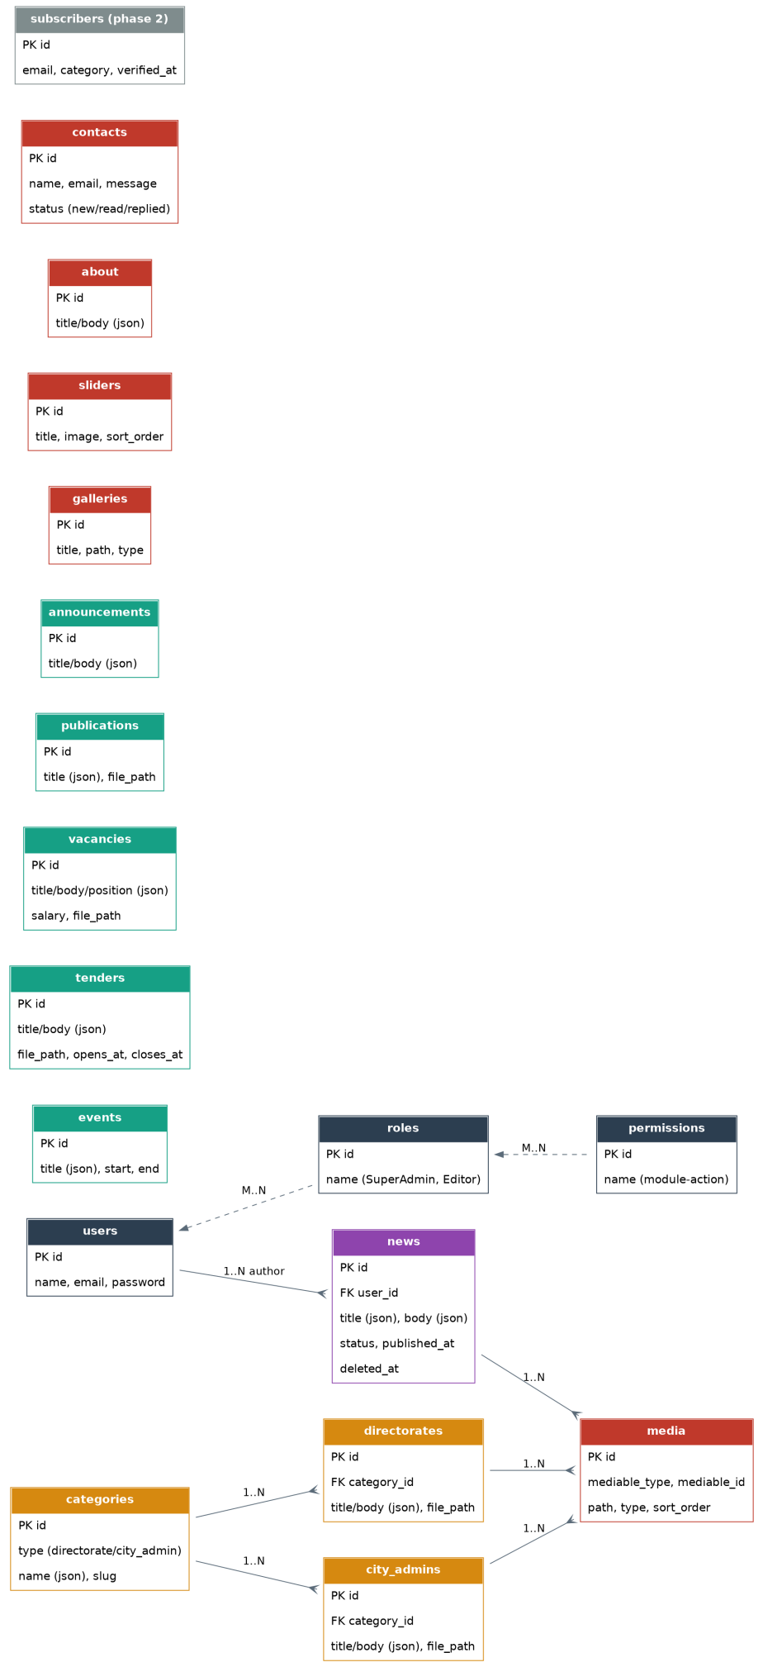
Figure 4. Target database schema.

4.1 Design decisions
Decision | Old approach | New approach | Classification
Bilingual content | Duplicate columns (title / titleamh) | Single JSON column, cast to array (title: {en, am}) | IMPROVES
Directory categories | Free-text model string per record | categories lookup table with type discriminator | IMPROVES
Per-record images | Three overlapping mechanisms (NewsImage, unfinished MultiImages, ad hoc gallery fields) | One polymorphic media table reused across modules | IMPROVES (consolidation)
Referential integrity | ->constrained() on plain columns, silently a no-op | Real foreignId()->constrained() with matching column types | IMPROVES
Deletes | Hard delete only | SoftDeletes (deleted_at) on all content tables | INTRODUCES
Publishing | Instantly live on save | status + published_at on News/Announcements | INTRODUCES
Indexing | None beyond primary keys | Indexes on published_at/closes_at/category_id + FULLTEXT for search | IMPROVES
Roles | One “Admin” role seeded despite granular permissions existing | Editor + Super Admin seeded, same permission names | IMPROVES

4.2 Migration approach from the existing database
Because this is a modernization of a live government system, the cutover plan treats the existing afar.sql content as the source of truth to migrate forward, not data to discard:
- Stand up the new schema in parallel with the old database (never in place).
- Write one-off ETL scripts per table: title + titleamh → {"en": title, "am": titleamh}; directorates.model / city_admins.model free-text values → deduplicated into the new categories table, then referenced by category_id.
- Re-point existing uploaded files (currently on local disk) into object storage, preserving their public URLs via redirects where feasible so old shared links/bookmarks (e.g. a tender download link shared on social media) don't break.
- Run both systems side by side against a copied dataset, diff the public-facing output page by page against the live site, then cut DNS over once verified.

5. API Architecture
The old system had no real API (routes/api.php exposed one endpoint). This is therefore introduced fresh, but shaped to serve exactly the modules the existing navigation already needs — no speculative endpoints beyond what the site and admin dashboard actually use, plus the small set of new features from the SRS (search, subscriptions).

5.1 Conventions
- Versioning: every route under /api/v1/. A breaking change ships as /api/v2/ alongside v1 rather than in place.
- Response envelope: { "data": ..., "meta": {...} } for collections (pagination info in meta), { "data": ... } for single resources, { "message": ..., "errors": {...} } for validation failures (Laravel's standard FormRequest error shape).
- Bilingual fields in responses: returned as nested objects, e.g. "title": { "en": "...", "am": "..." }, so the frontend picks the active locale client-side rather than the server guessing.
- Pagination: cursor or page-based (Laravel's built-in paginate()) on every list endpoint, page size capped server-side.
- Caching: public GET endpoints set Cache-Control headers and are additionally cached in Redis, invalidated on the matching module's create/update/delete.
- Rate limiting: stricter throttle on POST /contact and POST /subscribe (public write endpoints, the most likely spam targets) than on authenticated admin routes.
- Documentation: an OpenAPI 3 spec maintained alongside the FormRequest/Resource classes, used to generate the typed client both React apps consume — this is also what an AI coding tool should be pointed at when implementing frontend data-fetching hooks.

5.2 Endpoint map
Group | Endpoints | Auth
Public content (read) | GET /news, /events, /tenders, /vacancies, /publications, /announcements, /about, /directory, /directory/{category}, /gallery, /sliders — each with a matching /{id or slug} detail route | None
Downloads | GET /tenders/{id}/download, /vacancies/{id}/download, /publications/{id}/download, /directory/{id}/download — all return a signed, time-limited object-storage URL | None
Search | GET /search?q=... | None
Public write | POST /contact, POST /subscribe (phase 2) | None (rate-limited)
Auth | POST /auth/login, POST /auth/logout, GET /auth/me | Sanctum
Admin CRUD | POST/PUT/DELETE on every module above, under /admin/{module} | Sanctum + permission:{module}-{action}
Admin-only | GET /admin/contacts (+ PATCH status), GET /admin/activity-log, full CRUD on /admin/users, /admin/roles, /admin/categories | Sanctum + permission (users/roles: Super Admin only)

5.3 Classification
- [PRESERVES] Every URL a citizen or editor can currently reach a piece of content through still exists conceptually — the API is additive infrastructure, not a removal of capability.
- [INTRODUCES] The API itself, search, subscriptions, and the activity-log endpoint are all new surface area with no old equivalent.

6. Project Folder Structure
Three deployable units in one repository (a monorepo keeps the SRS/ERD/architecture docs, backend, and both frontends versioned together, which matters for an AI coding tool working across the whole system) — or three repositories if the team prefers fully independent deploy pipelines. Structure shown as a monorepo.

6.1 Repository root
afar-portal/
├── backend/ # Laravel 11/12 API
├── frontend-public/ # Next.js public site
├── frontend-admin/ # React + Vite admin dashboard
├── docs/
│ ├── SRS_Afar_Portal_v2.md
│ ├── erd_v2.png, arch_v2.png
│ └── openapi.yaml
└── docker-compose.yml # local dev: MySQL, Redis, MinIO (S3-compatible)

6.2 backend/ (Laravel)
backend/
├── app/
│ ├── Http/
│ │ ├── Controllers/Api/V1/ # NewsController, TenderController, ...
│ │ ├── Controllers/Api/V1/Admin/ # UserController, RoleController, ...
│ │ ├── Requests/ # one FormRequest per action
│ │ ├── Resources/ # NewsResource, TenderResource, ...
│ │ └── Middleware/
│ ├── Models/ # News, Tender, Vacancy, Directorate, Category, Media...
│ ├── Policies/
│ ├── Services/ # FileUploadService, TranslationService, SearchService
│ └── Jobs/ # SendSubscriptionAlert, ResizeImage
├── database/
│ ├── migrations/
│ ├── seeders/ # RolePermissionSeeder (Editor + Super Admin), CategorySeeder
│ └── factories/
├── routes/api.php
├── tests/Feature/Api/V1/ # one test file per module
└── config/

6.3 frontend-public/ (Next.js)
frontend-public/
├── app/
│ └── [locale]/
│ ├── page.tsx # Home
│ ├── about/page.tsx
│ ├── directory/
│ │ ├── page.tsx
│ │ └── [category]/[slug]/page.tsx
│ ├── news/[slug]/page.tsx
│ ├── events/page.tsx
│ ├── tenders/[slug]/page.tsx
│ ├── vacancies/[slug]/page.tsx
│ ├── publications/[slug]/page.tsx
│ ├── contact/page.tsx
│ ├── gallery/page.tsx
│ └── search/page.tsx
├── components/ # NavBar, Footer, Card, Pagination, FileDownloadButton...
├── components/AppPreloader/ # branded first-load screen (inlined critical CSS)
├── components/PageTransitionIndicator/# top progress bar for route/data transitions
├── components/skeletons/ # per-module content placeholders
├── lib/api-client/ # generated from openapi.yaml
├── lib/hooks/ # useNews, useTenders, ... (TanStack Query)
└── messages/{en,am}.json # static UI strings (nav labels, buttons)

6.4 frontend-admin/ (React + Vite)
frontend-admin/
├── src/
│ ├── pages/ # News, Events, Tenders, ... Users, Roles, ActivityLog
│ ├── components/forms/ # bilingual field pairs, FileUpload, RichText
│ ├── components/AppPreloader/, PageTransitionIndicator/ # shared pattern with public site
│ ├── lib/api-client/ # shared generation from the same openapi.yaml
│ ├── lib/auth/ # Sanctum SPA session handling
│ └── routes.tsx

7. Development Phases
Phase | Scope | Exit criteria
0. Foundation | Repo scaffolding, CI, Laravel API skeleton, auth + roles seeded, base schema/migrations, object storage + Redis wired, Next.js/Vite app shells with shared NavBar matching current site | A logged-in Editor can reach an empty admin shell; the public site renders Home/About with real navigation but placeholder content
1. Core content parity | News, Events, Tenders, Vacancies, Publications, Announcements, About — full API + both frontends | Every module a citizen relies on today works end-to-end on the new stack
2. Directory & media | Categories, Directorates, City Admins, unified media table, Gallery, Sliders | Directory section fully matches old category-filtered browsing
3. Engagement | Contact workflow (status/reply), Search, Activity log screen, Users/Roles admin | Full feature parity with the old system, plus the new engagement features
4. Migration & cutover | ETL from the existing afar.sql database, file migration to object storage, side-by-side verification, DNS cutover | Old and new systems produce matching public output; go-live
5. Phase 2 (optional) | Email subscriptions, Portfolio (if confirmed still needed), additional languages | Descoped from go-live without blocking it

8. MVP Scope for Supervisor Demonstration
The demo goal is to prove the architecture and the technology shift are real and working — not to reach feature parity. The MVP therefore takes a thin vertical slice through every layer (frontend, API, database, auth) using a small number of real navigation items, rather than one module built deeply.

8.1 In scope for the demo
- Public site: Home, About, News (list + detail), Tenders (list + detail + file download), Directory (one category, e.g. “Health”, with 2–3 sample entries), Contact (working submission) — covers the navigation shape end-to-end without requiring every module to be finished.
- Language switch between English and Amharic on at least the Home and News pages, proving the JSON-column i18n approach works.
- Admin dashboard: login screen, News list + create/edit (bilingual form), Tenders list + create/edit with file upload — enough to demonstrate the Editor workflow and the new FormRequest validation.
- One Editor and one Super Admin seeded account, demonstrating the permission split is real (e.g. Editor cannot see the Users screen).
- Responsive layout shown on a phone-width viewport for at least Home and News, demonstrating the “better responsiveness” goal concretely.
- A short before/after comparison slide: old Blade page vs. new React page for the same content, and a Lighthouse/accessibility score comparison if time allows — makes “better performance/accessibility” tangible rather than asserted.
- The branded first-load preloader and the top-of-page navigation indicator (§2.3), since they're highly visible, low-effort-to-build, and make the “modern, professional, government-appropriate” goal immediately obvious to a supervisor watching the demo.

8.2 Explicitly out of scope for the demo (build after, per the phased plan)
- Events, Vacancies, Publications, Announcements, Gallery, Sliders admin screens (same pattern as News/Tenders — low risk to defer).
- Search, email subscriptions, activity log screen, contact reply workflow.
- Data migration from the live afar.sql database (the demo can run on seeded sample data).
- Portfolio module (pending the usage confirmation noted in the SRS).

9. Technical Risks
Risk | Impact | Mitigation
Data migration from the old, structurally inconsistent schema (mixed PK types, unenforced FKs, free-text categories) into the new normalized schema | High — silent data loss or corruption during ETL | Write and dry-run ETL scripts against a copy of the real afar.sql early (phase 4 is deliberately last, but the scripts should be drafted and tested well before then); diff row counts and spot-check content per table.
SEO / link continuity during cutover | Medium — the public site has presumably been indexed and linked to (e.g. tender download links shared externally) under the old URL scheme | Preserve the same public URL shapes where feasible in the Next.js route design (§2.1 table maps old → new 1:1); add redirects for any URL that must change.
Amharic (Ge'ez script) rendering and input | Medium — font support, text direction, and input method must work correctly in React form fields and PDF/document generation if ever added | Verify font stack and input handling early, in phase 0, not discovered late in phase 1.
Team unfamiliarity with React/Next.js if the team has primarily worked in Blade/PHP | Medium — velocity risk during phases 1–3 | Start the admin SPA (simpler, no SSR concerns) before the public Next.js site to build React confidence on the lower-stakes app first.
Two React codebases drifting out of sync (duplicated component logic, mismatched validation rules vs. backend) | Medium — maintainability erosion over time, the exact failure mode this modernization is meant to fix | Shared, generated API client from one OpenAPI spec (§5.1); shared design-token package; validation schemas kept adjacent to the FormRequest rules they mirror.
Scope creep from the “added features” list (search, subscriptions) delaying core parity | Medium | Phase plan (§7) deliberately sequences all new features after core parity; phase 5 items are explicitly optional/descopable.
File storage cutover (local disk → object storage) breaking existing download links mid-migration | Medium | Run both storage backends in parallel during phase 4; verify every download URL before decommissioning local disk.
No existing automated tests to compare behavior against | Medium — hard to prove “same behavior, better technology” without a baseline | Write feature tests against the *old* system's current behavior first (or at minimum a manual test-case checklist per module) before rebuilding it, so parity is verifiable rather than assumed.
Branded preloader/transition indicator tuned poorly (shown too long, or flashing on fast connections) undermines the “perceived performance” goal it's meant to serve | Low-Medium — cosmetic but visible on every single page load | Use the minimum/maximum display-time guardrails in §2.3.1 as configuration values, not hard-coded; validate against real network conditions (throttled 3G and fast fibre) before launch, not just on developer machines.

10. Implementation Roadmap
Indicative sequencing (adjust durations to actual team size/velocity — shown as relative order and dependencies, which matter more than calendar time at this stage).
Step | Milestone | Depends on | Demo-relevant?
1 | Repo, CI, Docker dev environment (MySQL, Redis, MinIO) running locally | — | No
2 | Laravel API skeleton + Sanctum auth + roles/permissions seeded (Editor, Super Admin) | 1 | Yes — needed for admin login demo
3 | Base schema migrated (News, Tenders, Categories, Directorates — MVP subset first) | 2 | Yes
4 | Admin SPA shell + login + News CRUD + Tenders CRUD (with file upload) | 2, 3 | Yes — core of the demo
5 | Public Next.js shell + NavBar matching existing IA + Home/About/News/Tenders/Directory(1 category)/Contact | 3 | Yes — core of the demo
6 | Bilingual toggle wired end-to-end (JSON columns → API → both frontends) | 4, 5 | Yes
7 | Responsive + baseline accessibility pass on demo pages | 5 | Yes
8 | → Supervisor demonstration checkpoint (MVP per §8) | 1–7 | —
9 | Remaining core modules: Events, Vacancies, Publications, Announcements | 3–5 | No
10 | Gallery, Sliders, full Directory categories, unified media table | 9 | No
11 | Contact workflow, Search, Activity log screen | 9 | No
12 | ETL scripts drafted + dry-run against copied production data | 3 (can start early, in parallel) | No
13 | Full data migration, side-by-side verification, DNS cutover | 9–12 | No
14 | Phase 2 (optional): subscriptions, Portfolio decision, additional languages | 13 | No

Notes on this document
This architecture is derived from the project SRS (SRS_Afar_Portal_v2.md) and the earlier source-code audit of the existing Laravel 8 system. Every “old equivalent” referenced above (routes, controllers, schema) reflects what was found by reading the original codebase directly, not an assumption about what a typical system of this kind would contain.

